Exercise 2

Q.1Develop a program that accepts the names, quantities, and prices of three grocery items, calculates the total bill amount, and displays the final bill in a formatted mann

name1 = input("Enter item 1 name: ")

qty1 = int(input("Enter quantity: "))

price1 = float(input("Enter price: "))

name2 = input("Enter item 2 name: ")

qty2 = int(input("Enter quantity: "))

price2 = float(input("Enter price: "))

name3 = input("Enter item 3 name: ")

qty3 = int(input("Enter quantity: "))

price3 = float(input("Enter price: "))

total = (qty1 * price1) + (qty2 * price2) + (qty3 * price3)

print("\n----- GROCERY BILL -----")

print(name1, qty1, price1, qty1 * price1)

print(name2, qty2, price2, qty2 * price2)

print(name3, qty3, price3, qty3 * price3)

print("------------------------")

print("Total Bill =", total)

output

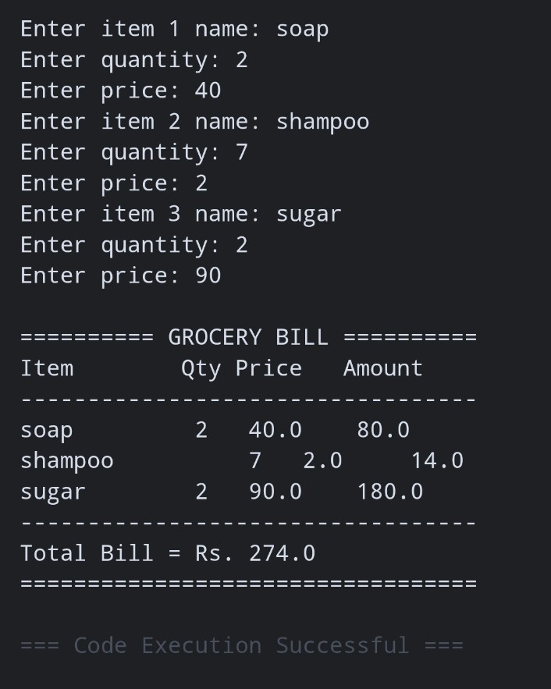

Q.2 Create a program that accepts the total purchase amount and applicable discount percentage, calculates the discount amount and final payable amount, and displays a formatted billing summary

.amount = float(input("Enter total purchase amount: "))

discount = float(input("Enter discount percentage: "))

discount_amount = amount * discount / 100

final_amount = amount - discount_amount

print("\n----- BILLING SUMMARY -----")

print("Purchase Amount =", amount)

print("Discount =", discount, "%")

print("Discount Amount =", discount_amount)

print("Final Payable Amount =", final_amount)

output

